EVENTOS
EMPRESA

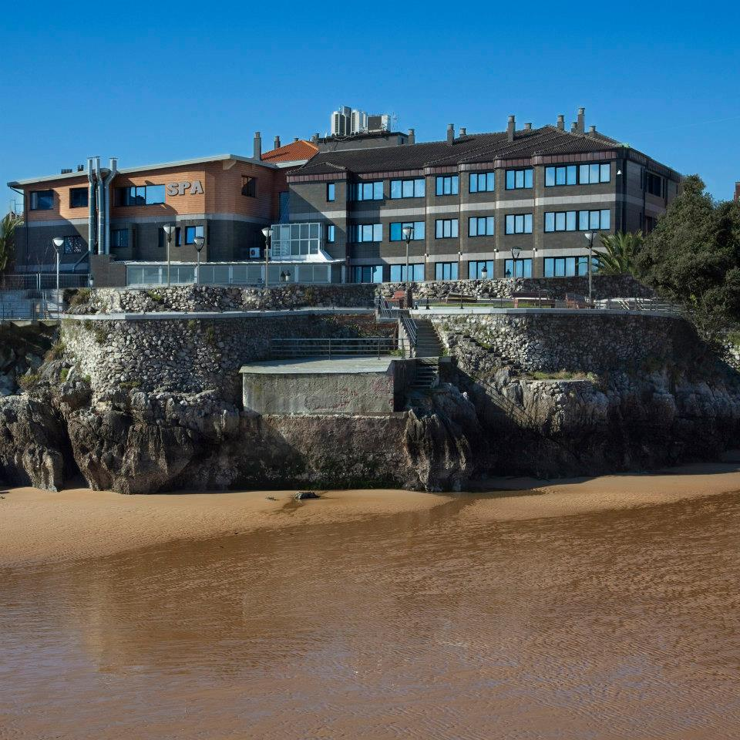
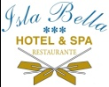
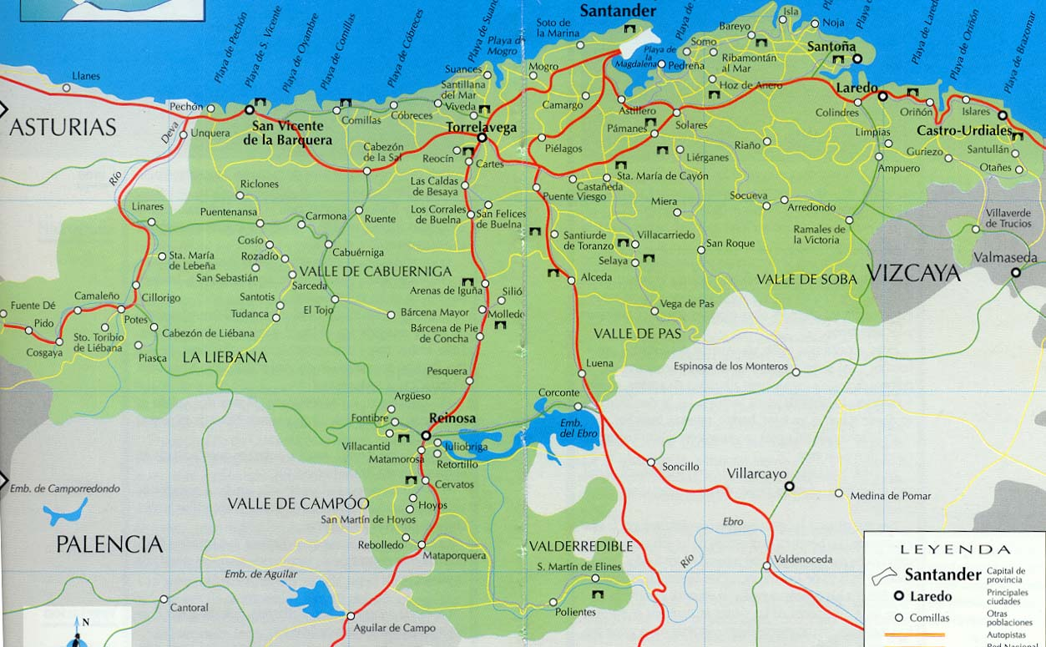
¿DÓNDE ESTAMOS?
Cuando se organiza cualquier evento empresarial son muchos los factores que deben tenerse en cuenta, y la elección del lugar es uno de los más influyentes.
El Hotel Isla Bella se ubica a la orilla de la Playa del Sable, a apenas 30 minutos del Aeropuerto de Santander y 30 minutos de la capital. Por su excelente ubicación y cómodas comunicaciones se accede fácilmente desde la autovía del Cantábrico (A-8), desde Bilbao se llega en apenas 50 minutos.
Si vas a organizar próximamente un evento de empresa y te atreves con algo diferente ¿Por qué no lo celebras con nosotros?
En el Hotel Isla Bella & Spa tendrás un lugar distinto para celebrarlo, nosotros nos adaptamos al objetivo y carácter de tu evento y a precios muy competitivos

Situado en primera línea de la playa de Isla, en un enclave excepcional, el Hotel Isla Bella & Spa cuenta con varios espacios diseñados especialmente para que todo salga perfecto.

¡Nuestro servicio profesional y una cocina de reconocido prestigio harán que tu evento de empresa en el Hotel Isla Bella & Spa sea todo un éxito!
SALONES | Salón  Cantabria | Salón Olimpo
Banquetes / Banquet | 160 | 40
Cocktail | 220 | 60
Teatro / Theater Style | 190 | 40
Aula / Classroom | 110 | 30
Mesa "U" / "U" Style | 60 | 22
Mesa Imperial/Boardroom | 60 | 22
Superficie/m2 | 230 | 50
¿QUÉ EVENTOS DE EMPRESA PUEDO REAIZAR?
Comidas y Cenas empresariales
Ruedas de Prensa
Lanzamiento y presentación de productos
Reuniones y Presentaciones de empresa
Reuniones con clientes o proveedores
Showrooms
Cursos de Formación
Galas Benéficas
Otros eventos, no dude en consultarnos sin ningún compromiso.
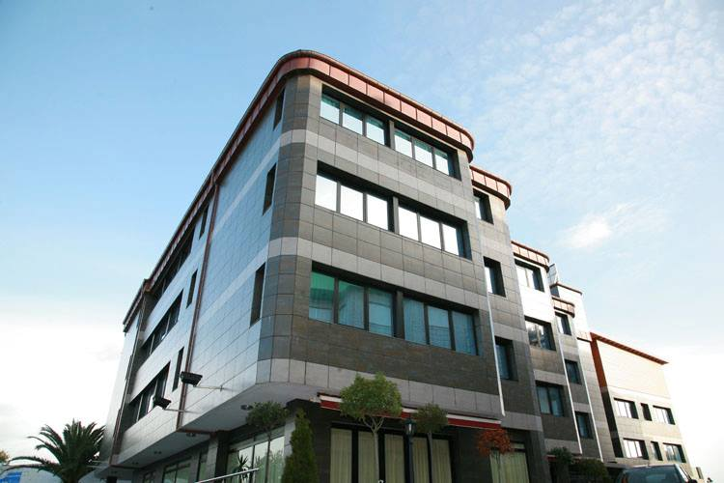
Restaurante de reconocido prestigio en Cantabria con una cocina tradicional. Desde nuestro restaurante podrá disfrutar del Cantábrico en su mesa.
Además Ofrecemos servicio de cafetería, Terraza y Discoteca
Alojamiento, en el Hotel Isla Bella & Spa ponemos a su disposición 62 habitaciones dotadas con el máximo confort, algunas de ellas con impresionantes vistas al mar. Todas están equipadas con televisión, aire acondicionado, calefacción, mini-bar, caja fuerte gratuita y secador de pelo.
Spa
Otros Servicios: Parking Exterior Gratuito, WiFI gratuito, Servicio de Lavandería…
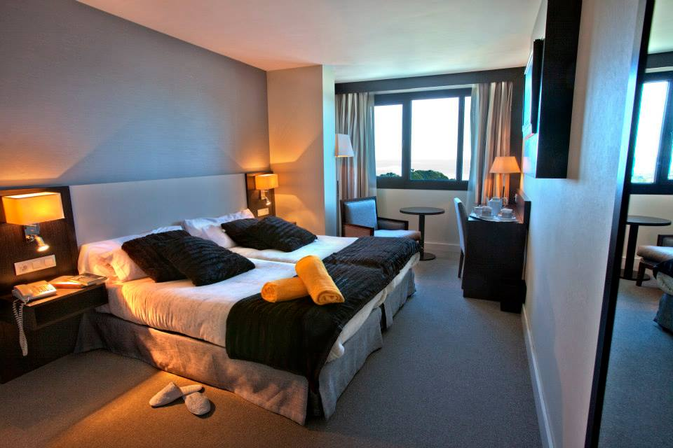
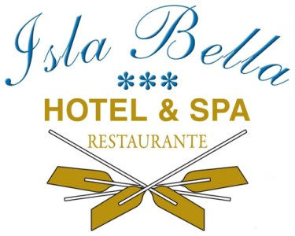

Hotel Isla Bella ***
Restaurante & Spa
Paseo el Sable,2
39195 Isla
CANTABRIA
T. 942 67 93 06
F. 942 67 93 72
islabella@hotelesdecantabria.com

